Practical -1 Basic HTML Tags

1. Create an HTML web page which displays the effects and use of following tags. Also write the importance of each tag with its attributes in comment section.
   1. <HTML>
   2. <HEAD>
   3. <Body>
   4. <Title>
   5. <i>
   6. <b>
   7. <u>
   8. <p>
   9. <pre>
   10. <a>
   11. <img>
   12. <br>
   13. <h1>
   14. <hr>
   15. <sub>
   16. <sup>
   17. <small>
   18. <em>
   19. <strong>
   20. <mark>
   21. <del>
   22. <ins

**HTML Code**

<!--The text between <html> and </html> describes an HTML document-->

**<html>**

<!-- The text between <head> and </head> provides information about the HTML document-->

**<head>**

<!-- The text between <title> and </title> provides a title for the HTML document -->

**<title>Basic html tags</title>**

**</head>**

<!-- The text between <body>describes the visible page content i.e. the content which is visible in the browser. The <body> element contains all the contents of an HTML document, such as headings, paragraphs, images, hyperlinks, tables, lists, etc. -->

**<body>**

<!-- The <i> tag defines a part of text in an alternate voice or mood. The content inside is typically displayed in italic. -->

**<i>Text in italics</i>**

**<br>**

<!-- The <b> tag specifies bold text without any extra importance. -->

**<b>Text in bold</b>**

**<br>**

<!-- The <u> tag represents some text that is unarticulated and styled differently from normal text, such as misspelled words or proper names in Chinese text. The content inside is typically displayed with an underline -->

**<u>Underlined Text</u>**

<!-- The <br> tag inserts a single line break. The <br> tag is an empty tag which means that it has no end tag. -->

**<br>**

<!-- The text between <p> and </p> describes a paragraph -->

**<p>This is a paragraph</p>**

<!-- The <pre> tag defines preformatted text. -->

**<pre>**

**This is pre**

**Tag. \*\*\*\*\*\*\*\***

**</pre>**

<!-- The <a> tag defines a hyperlink, which is used to link from one page to another. -->

**<a href="">This is a hyperlink</a>**

**<br>**

<!-- The<img>tag is used to embed an image in an HTML page.-->

**<img src="1.jpeg" alt="" height="200" width="200">**

<!-- The text between <h1> and </h1> describes the main heading. The <h1> to <h6> tags are used to define HTML headings. <h1> defines the most important heading. <h6> defines the least important heading. -->

**<h1>Heading 1</h1>**

**<h2>Heading 2</h2>**

**<h3>Heading 3</h3>**

**<h4>Heading 4</h4>**

**<h5>Heading 5</h5>**

**<h6>Heading 6</h6>**

<!-- The <hr> element is most often displayed as a horizontal rule that is used to separate content (or define a change) in an HTML page. -->

**<hr>**

<!-- The <sub> tag defines subscript text. Subscript text appears half a character below the normal line, and is sometimes rendered in a smaller font. Subscript text can be used for chemical formulas, like H2O. -->

**<p>H<sub>2</sub>O</p>**

<!-- The <sup> tag defines superscript text. Superscript text appears half a character above the normal line, and is sometimes rendered in a smaller font. Superscript text can be used for footnotes, like WWW[1]. -->

**<p>a<sup>2</sup>+ b <sup>2</sup>= c<sup>2</sup></p>**

<!-- The <small> tag defines smaller text (like copyright and other side- comments). -->

**<p>Example of <small><small>small</small></small> tag</p>**

<!-- The <em> tag is used to define emphasized text. The content inside is typically displayed in italic. -->

**<p>This text is <em>emphasized</em></p>**

<!-- The <strong> tag is used to define text with strong importance. The content inside is typically displayed in bold -->

**<p>This is <strong>strong</strong> tag</p>**

<!--The<mark>tag defines text that should be marked or highlighted-->

**<p>This text is <mark>highlighted</mark></p>**

<!-- The <del> tag defines text that has been deleted from a document. Browsers will usually strike a line through deleted text.-->

**<p>This text is <del>deleted</del></p>**

<!-- The <ins> tag defines a text that has been inserted into a document. Browsers will usually underline inserted text. -->

**<p>This text is <ins>newly inserted</ins></p>**

**</body>**

**</html>**

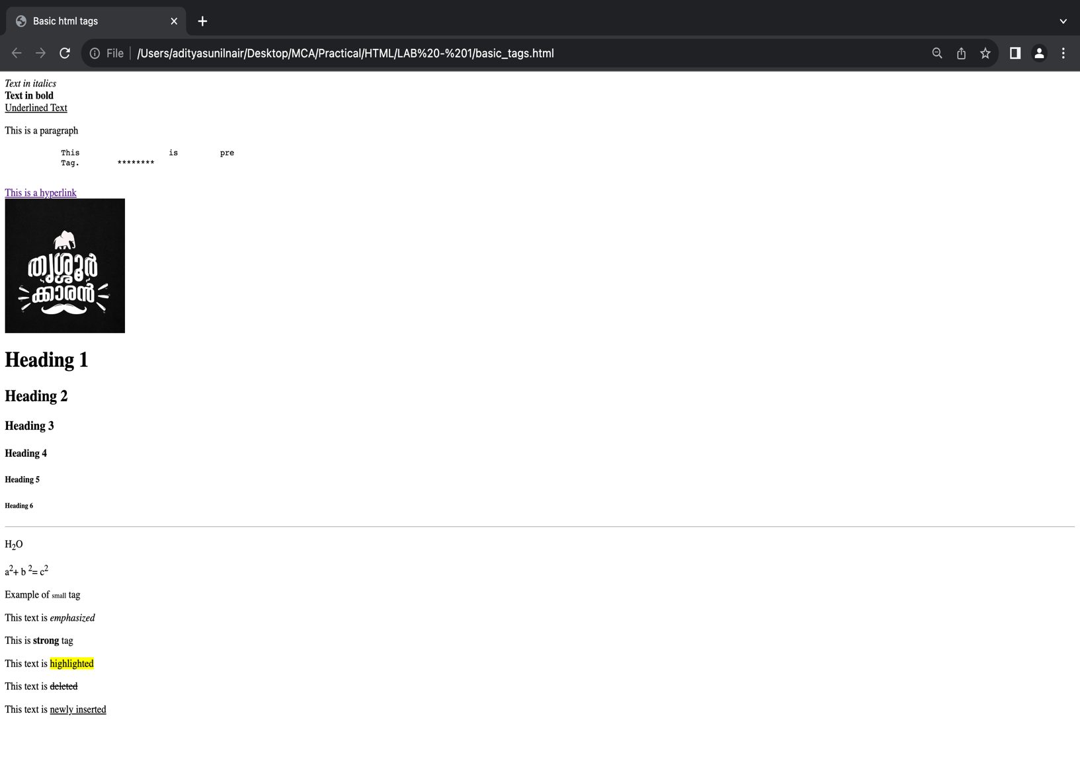***Output***